Year 12 ATAR Human Biology ATHBY
Task 8: Science Inquiry
Conditions: You have been provided with a modified research paper. Read the information carefully. Tomorrow you will be required to answer a series of questions relating to the research. The questions will be completed during class time. Text book and handwritten notes permitted.
Time for task: 40 min
Task weighting: 3 % Total Marks:20

Introduction
Since identification of the CFTR gene over 25 years ago, gene therapy for cystic fibrosis (CF) has been actively developed. Gene therapy is currently the most advanced form of CF genetic medicine. Since cloning of the CFTR gene in 1989 extensive pre-clinical research led to approximately 27 clinical trials involving about 600 patients being completed.

Recently, a double-blind, placebo-controlled multi-dose trial was carried out to test the effectiveness of liposome vectors in carrying the normal CFTR gene into cystic fibrosis suffers.

Patients 12 years or older with moderate or mild lung disease as a result of cystic fibrosis received 5 ml of nebulized pGM (normal CFTR gene in a liposome vector) or 5 ml 0.9% saline every month for 12 months.

The scientists measured the change in lung function of patients as a relative change of percent predicted forced expiratory volume in 1 second (FEV₁). Lung function (FEV₁) was measured at each visit before administration of the treatment.

Data from 116 patients (who received nine or more doses) were analysed and the results are presented on the graphs below. Data are expressed as relative percent change from the baseline FEV₁. Error bars show the standard error of the mean.

- All patients receiving treatment

(B) Patients with more severe reduced lung function at start of treatment
(Baseline FEV₁ 50–70%)

(C) Patients with less severe reduced lung function at start of treatment
(Baseline FEV₁ 70–90%)

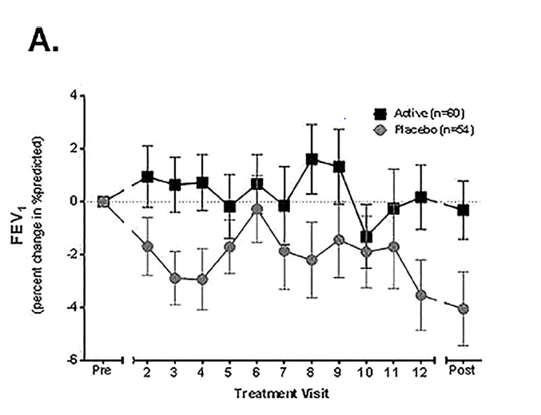
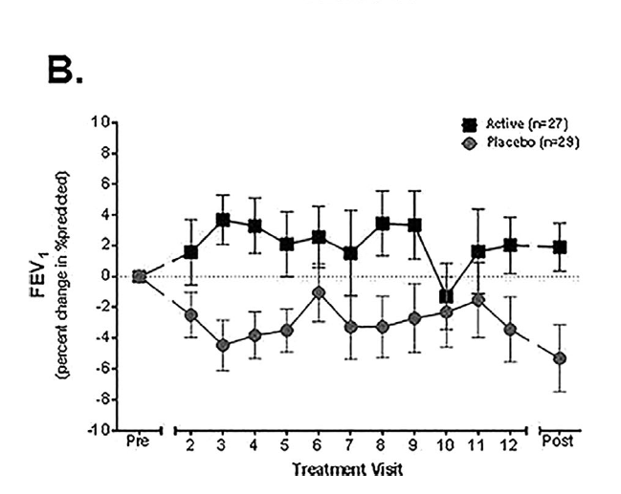

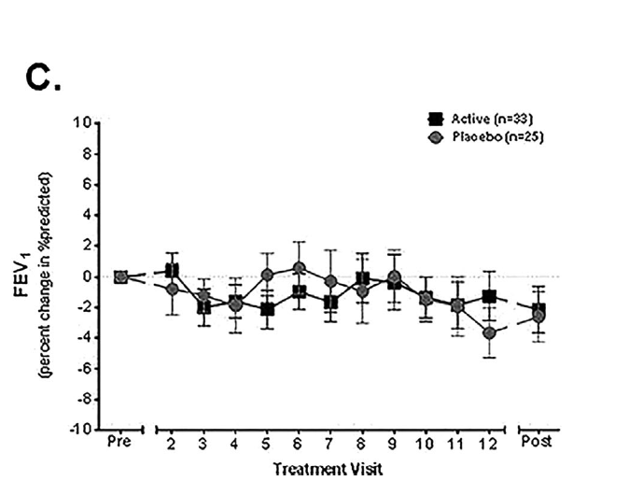
Questions

- Propose a hypothesis for this experiment. 2 marks
Any valid Hypothesis –identifies relationship b/w independent and dependent variable and testable

- Define ‘placebo’. 2 marks
A fake/inactive treatment. (1 mark)
It is administered to a control group in an experiment. This group then acts as a comparison to the experimental group. (1 mark)

- What was the placebo treatment administered during this research? 2 marks
5ml of nebulized 0.9% saline
0.9% saline (1 mark)
5ml nebulized (1 mark)

- Explain the term ‘double-blind’ and why researchers would use this approach. 3 marks
Researchers and patients are not aware who receives the placebo treatment or the experimental treatment. (1 mark)
Prevents bias from the researchers influencing analysis of the data (1 mark)
and ensures results are not simply because the patient has an expectation that the treatment will work(placebo effect) (1 mark)

- With reference to the data provided, state two conclusions that can be drawn from the experiment. 4 marks
Two of the following
Any valid trend (1 mark per trend)
Uses data to support trend identified (1 mark per trend)

- Error bars are graphical representations of the variability of data and are used on graphs to indicate the error or uncertainty in a reported measurement. What is the benefit of using error bars? 2 marks
Error bars on graphs indicate the error or uncertainty in a reported measurement. They give a general idea of how reliable a measurement is, or conversely, how far from the reported value the true (error free) value might be. (1 mark)
Quick visual representation for scientist to review data (1 mark)

- Explain why scientists would include a post-treatment measurement. 2 marks
Indicates longer term impact of treatment (1 mark)
Acts as a comparison (1 mark)

8 After considering the data and your conclusions, what treatment advice would you provide to a patient with less severe lung function (Baseline FEV₁ 70–90%). Explain your response, referring to data provided. 3 marks
Recommend that they do not receive treatment with the pGM. The results indicated there was no difference between the placebo and experimental group. (1 mark)
Both groups FEV₁ decreased (1 mark)
by -2% (1 mark) any appropriate data

